

Forged Coders

Emergency Help

Software Requirements Specification

Version <1.1>

Submitted in Partial Fulfillment for the Award of Degree of Bachelor of Technology in Information Technology from Rajasthan Technical University, Kota

MENTOR:

Dr.Saroj Agarwal

(Dept. of Information Technology) COORDINATOR:

Mrs.Priyanka Yadav

(Dept. of Information Technology)

SUBMITTED BY:

Anirudh Soni (21ESKIT016) Aditya Mishra (21ESKIT006)

Chetan Singh (21ESKIT033)

DEPARTMENT OF INFORMATION TECHNOLOGY

SWAMI KESHWANAND INSTITUTE OF TECHNOLOGY, MANAGEMENT & GRAMOTHAN

Ramnagaria (Jagatpura), Jaipur — 302017

SESSION 2024-25

Revision History

|  |  |  |  |
| --- | --- | --- | --- |
| Date | **Version** | **Description** | **Author** |
| 02/12/2024 | 1.1 | Requirement Gathering and  **Analysis:**   * Identify the key functionalities and features required for the "Emergency Help App." * Collaborate with stakeholders to understand user needs and expectations. | Anirudh Soni  Aditya Mishra  Chetan Singh Rathore |
| 02/12/2024 | 1.1 | **Technology Stack Selection:** | Anirudh Soni |
|  |  | * Evaluate and finalize the tools, frameworks, and APIs to be used, such as Firebase and Google Maps. * Ensure compatibility with the target platform (Android). The "Emergency Help App" is a mobile application designed to assist users during emergencies by providing timely and accurate help. The app integrates real-time location tracking, SOS alerts, and communication capabilities to ensure that users can quickly connect with the necessary support systems during critical situations. | Aditya Mishra  Chetan Singh Rathore |

```

Table of Contents

|  |  |  |  |
| --- | --- | --- | --- |
| 1. Introduction |  | 3 |  |
| * 1. Purpose   2. Scope   3. Definitions, Acronyms and Abbreviations   4. References   5. Technologies to be used   6. Overview |  | 3 |
| 2. Literature survey |  |  | 5 |
| 2.1 Review of Related Work |  |  |  |
| 2.2 Knowledge gaps |  |  |  |
| * 1. Comparative Analysis   2. Summary | 6 |  |  |
| 3. Specific Requirements |  | 7 |  |
| * 1. Functional Requirements   2. Non- Functional Requirements   3. Hardware Requirements   4. Software Requirements   5. Agile Methodology   6. Business Process Model   7. Supplementary Requirements |  | 5 |  |

1. System Architecture
   1. Client-Server Architecture
   2. Communications Interfaces
2. Design and Implementation 13
   1. Product feature
   2. Data Flow diagram
   3. E-R Diagram
   4. Class Diagram
   5. Use-Case Model Survey
   6. Behaviors Diagrams
   7. Database Diagram
   8. Assumptions and Dependencies
3. **Supporting Information** 22
4. **Conclusion & Future scope** 23
5. Concerns / Queries / Doubts if any:

2

### Introduction

In emergencies, time is of the essence, and the ability to request immediate assistance can save lives. The **Emergency Help** App is a cutting-edge solution designed to bridge the gap between those in need and responders, providing a fast, reliable, and accessible platform for emergency help.

The application is built with a user-friendly interface and integrates advanced technologies to ensure swift communication during critical situations. By leveraging features such as geolocation tracking, automated alerts, and multi-channel communication, the Emergency Help App aims to empower users to alert authorities, loved ones, or relevant emergency services at the touch of a button.

The core objective of this project is to achieve a high level of accuracy in locating users and delivering timely assistance, ensuring the safety and security of individuals in distress. Designed with scalability and reliability in mind, the Application is adaptable for use in various scenarios, including medical emergencies, natural disasters, and personal safety threats.

With the increasing need for efficient emergency systems, this application not only fills a critical gap but also redefines the way emergency services are delivered in today's fast-paced world.

* 1. Purpose

The Emergency Help App is designed to provide an immediate, reliable, and efficient platform for requesting and receiving help during emergencies. Its purpose can be outlined as follows:

1. Quick Response in Emergencies

* To enable individuals to swiftly alert emergency services, authorities, or designated contacts with minimal effort, ensuring timely intervention during critical situations.

1. Enhanced Safety and Security

* To create a sense of security by offering a dependable tool for users to request assistance, whether in cases of medical emergencies, natural disasters, accidents, or personal threats.

1. Accurate Location Tracking

* To utilize geolocation technology to pinpoint the user’s exact location and share it withresponders, minimizingdelays and improving rescue outcomes.

1. Streamlined Communication

* To facilitate seamless communication between users and responders through automated alerts and updates, ensuring all parties are informed and connected.

1. Accessibility for All Users

* To provide a user-friendly interface that is accessible to people of all ages and technical abilities, making it a practical solution for diverse user groups.

1. Preparedness and Awareness

* To promote proactive measures by allowing users to store critical information**,** such as medical history or emergency contacts, for quick reference during emergencies.

1. Support in Diverse Scenarios

* To serve as a versatile tool adaptable to various emergency contexts, from individual safety concerns to large-scale disasters.

The primary goal of the Emergency Help App is to save lives, enhance the effectiveness of emergency response systems, and provide peace of mind to users, ensuring help is always just a tap away.

* 1. **Scope**

The Emergency Help App is a comprehensive emergency response and safety management tool designed to address diverse crises effectively. It enables users to send instant alerts to emergency services, family members, or

designated contacts whilesharing real-time location information for swiftassistance. The application targets a wide range of users, including individuals, healthcare providers, disaster management agencies, educational institutions, and workplace environments, ensuring safety across various scenarios. With cross-platform accessibility, cloud integration, and potential for Al-driven enhancements, the Emergency Help App is scalable and adaptable to different regions and emergency systems, making it a vital solution for modern safety and crisismanagement.

* 1. **Definitions, Acronyms and Abbreviations**
* SRS: Software Requirements Specification
* API: Application Programming Interface
* UI: User Interface
* DBMS: Database Management System
* IoT: Internet of Things
  1. **References**

This SRS references industry standards, project management practices, and external documents or specifications used in defining the requirements for the "Emergency help" platform.

* 1. **Technologies to be used**

Java: The primary programming language for the application’s logic.

Android SDK: Framework used to build the application for Android devices.

XML: Used for designing layouts and defining resources (e.g., AndroidManifest.xml).

Gradle: Build automation tool to manage dependencies and build configurations.

Firebase: Integrated for database or backend services (detected in configuration files).

Google Maps API: Likely used for location services and map integration in the app.

Material Design Components: Provides modern UI/UX elements for Android apps.

* 1. Overview

The Emergency Help Application is a mobile solution designed to provide immediate assistance during critical situations. It leverages advanced technologies to ensure a

communication between individuals in distress and emergency responders, such as family, friends, or authorities. With user-friendly features like real-time location sharing, automated alerts, and SOS signal activation, the app aims to enhance personal safety and reduce response times in emergencies.

The app’s primary focus is on accessibility, reliability, and speed, ensuring users can activate help with minimal interaction. By integrating mapping services, backend communication, and intuitive design, the Emergency Help App serves as a vital tool for addressing safety concerns in a connected and efficient manner.

1. **Literature survey**

The development of an Emergency Help Application builds on the foundation of existing systems and technologies designed to provide quick and reliable assistance during crises. Traditional methods, such as helplines, have been effective but are often slow and prone to delays. Modern SOS applications like *bsafe* and *Life360* address these gaps with features like real-time location sharing and automated alerts, yet they face challenges in accuracy, integration with local services, and user adoption. Emerging technologies, including AI for predictive analytics, IoT for wearable device integration, and

cloud-based services for real-time communication, offer opportunities to enhance these applications.

* 1. **Review of Related Work**

This section reviews existing effort tracking systems to understand the landscape:

**Overview of Existing Systems:**

Tools like Java, XML, and Gradle are commonly used in organizations to track employee activities. These systems allow task assignment, time logging, and reporting.

Java: The primary programming language for the application's logic.

XML: Used for designing layouts and defining resources (e.g., AndroidManifest.xml).

Gradle**:** Build automation tool to manage dependencies and build configurations.

**Key Functionalities:**

* **Task Assignment:** Assigning tasks to employees and tracking their progress.
* Time Logging: Recording the number of hours spent on tasks.
* Reporting: Generating reports on productivity and task completion.

**Limitations in Current Systems:**

* High cost for premium features.
* Limited customization options for specific organizational workflows. Complexity in setting up and using for smaller teams or organizations.

**Relevance to the Emergency Help App:**

Unlike these tools, your system emphasizes simplicity, efficiency, and a focus on summarizing employee activities, total hours spent, and percentage efficiency.

* 1. **Knowledge gaps**

This section identifies gaps in existing tools that your system addresses:

**Over-complication of Tools:** Many existing systems are feature-heavy, which makes them unsuitable for smaller organizations or straightforward tracking needs.

Efficiency Metrics: Current tools often lack the ability to calculate and display percentage efficiency clearly and intuitively.

**Custom Reporting:** Limited flexibility in customizing reports based on organizational requirements.

Cost and Accessibility: The high cost of popular tools makes them inaccessible to smaller organizations or startups.

Your Emergency Help App addresses these gaps by focusing on ease of use, clear efficiency metrics, and simplified reporting.

* 1. **Comparative Analysis**

**Feature**

**Proposed Emergency**

Help App

**bsafe Life360 MySOS**

**Programming Language**

**Development Framework**

Java (Native Android) Native Android & Native Android & Native Android & iOS iOS iOS

Android SDK Android SDK, iOS Android SDK, iOS Android SDK, iOS SDK SDK SDK

**Location Services** Google Maps API Google Maps API Google Maps API Google Maps API

**Backend Support** Firebase (real-time Cloud-based

database) services

Cloud-based services

Cloud-based services

**SOS Activation**

Methods

Single-tap, voice activation, IoT

Voice activation, Single-tap single-tap

Single-tap

**Integration with IoT** Yes (Wearable devices Limited support)

Limited No

**Predictive Analytics**

**Real-Time Alerts**

AI for risk prediction No

Multi-channel SMS and app notifications (SMS, notifications app)

No No

SMS and app SMS and app

notifications notifications

**Privacy and Security**

Encrypted location and Limited encryption Limited user data encryption

Limited encryption

**Scalability**

High (Cloud and modular architecture)

Medium

Medium

Medium

**Customizability**

Highly customizable Limited (user profiles)

Moderate

Limited

* 1. **Summary**

The **Emergency Help Application** is a comprehensive mobile tool designed to provide immediate and efficient assistance during emergencies. Built with Java and leveraging the **Android SDK,** the app offers features that prioritize user safety, rapid response, and seamless connectivity with emergency services. It uses Google Maps API for precise location tracking and Firebase for real-time data handling, ensuring quick communication between users and responders.

Key functionalities include single-tap and voice-activated SOS signals, integration with wearables for discreet activation, and multi-channel alerts via SMS and app notifications. The application incorporates **Al-driven predictive analytics** for risk assessment and uses secure data encryption to protect user privacy. Its modular architecture ensures scalability, allowing it to adapt to different user needs and expanding emergency response scenarios.

The app stands out by addressing the shortcomings of existing emergency solutions through enhanced features such as real-time location sharing, advanced integration options, and robust security measures, making it a reliable and forward-thinking tool for personal safety and crisis management.

#### Specific Requirements

* 1. An emergency help application should have a simple, intuitive, and user-friendly interface that allows users to quickly call for assistance with minimal steps. It must include a one-touch emergency button that enables instant communication with

emergency services or pre-set contacts and the ability to send automated SMS alerts with the user’s real-time location. Integration with GPS and mapping services is essential for location tracking and sending precise coordinates to emergency responders. The app should feature user profile management to store essential personal details and emergency contact information, along with customizable alerts for specific situations. Security and privacy are paramount, so robust data encryption, privacy controls, and optional two-factor authentication must be incorporated. The app should function even in offline mode to ensure basic emergency features are accessible without internet connectivity. Additional support could include a silent alert mode, live chat with emergency services, and first aid guidance for immediate response. Compliance with data protection regulations, like GDPR or HIPAA, is crucial to protect user data, and the app should be regularly tested to ensure reliability under high-stress conditions. Integration with local emergency services for seamless coordination and cloud-based data storage for synchronization across devices are also key technical requirements. Finally, accessibility features, including multi-language support and compatibility with assistive technologies, will make the app usable for a wider range of individuals, including those with disabilities.

* 1. **Functional Requirement**

The functional requirements for an emergency help application include a range of features that ensure rapid and effective response during critical situations. The app must provide a one-touch emergency button that immediately initiates contact with emergency services or pre-selected emergency contacts, along with the option to send pre-set messages containing the user's location and other key information. It should incorporate GPS and mapping functionality to provide real-time location tracking, ensuring that emergency responders can pinpoint the user’s location quickly and accurately. The app must support real-time alerts and notifications to both the user and their emergency contacts, notifying them when help has been summoned or when an emergency has been resolved. User profile management is essential, allowing users to input and update personal information such as medical history, blood type, and emergency contacts. Security features, such as data encryption, two-factor authentication, and privacy controls, must be integrated to protect user data and maintain user trust. The app should be able to function in offline mode with basic emergency services, ensuring access even without an internet connection. It should also support custom alert settings, allowing users to specify the type of notifications they wish to receive. Other functional elements include live chat capabilities with emergency services, first aid guidance, and the ability to discreetly alert contacts without drawing attention. To comply with regulations, the app should include consent management for user data processing, as well as a logging and reporting feature for incidents and usage history. Additionally, the app should be tested for performance under real-world conditions, supporting cross-platform compatibility to cater to iOS, Android, and other devices.

* 1. Non Functional Requirements

Non-functional requirements (NFRs) for an emergency help application focus on the overall quality and performance characteristics that contribute to the effectiveness, usability, and dependability of the app. These requirements are essential to ensure that the app works as expected under varying conditions, especially in high-pressure situations. Here are key non-functional requirements for an emergency help application:

1. Performance and Scalability
   * High Availability: The app should be accessible at all times with a target uptime of 99.9% or higher to ensure that users can rely on it during emergencies.
   * Low Latency: The app must have fast response times (e.g., under 2 seconds) for emergency actions like sending alerts and initiating calls.
   * Scalability: The infrastructure should be scalable to handle increased user traffic, especially during large-scale emergencies or high-stress periods.
2. Reliability and Robustness
   * Error Handling and Recovery: The app should have robust error-handling mechanisms that ensure the system can recover gracefully from failures without compromising core functionalities.
   * Backup and Data Recovery: There must be a reliable data backup and recovery system to prevent data loss and ensure continuity in case of hardware failure or other incidents.
   * Redundancy: Critical components should be redundant to prevent service disruption in case of hardware or software failures.
3. Security
   * Data Encryption: All user data should be encrypted during transmission and storage to protect sensitive information.
   * Authentication and Authorization: Strong user authentication (e.g., two-factor authentication) should be implemented to ensure that only authorized users have access to their accounts.
   * Privacy and Compliance: The app must comply with data protection regulations such as GDPR or CCPA to safeguard user privacy and ensure legal adherence.
   * Secure APIs: APIs used for third-party services should be secured to prevent unauthorized access and data breaches.
4. Usability and Accessibility
   * User-Friendly Design: The app should have a simple and intuitive user interface, making it easy for users to navigate and access emergency features, even under stress.
   * Accessibility: The app should meet accessibility standards (e.g., WCAG) to

support users with disabilities, including features like screen readers, voice commands, and adjustable text sizes.

* + Multi-Language Support: The app should be available in multiple languages to serve a diverse user base effectively.

1. Maintainability and Support
   * Modular Architecture: The app should be designed with a modular architecture that allows for easy updates and maintenance.
   * Detailed Documentation: Comprehensive documentation should be provided for both end-users and developers to facilitate troubleshooting, updates, and future enhancements.
   * Regular Updates: The app should be regularly updated to fix bugs, patch vulnerabilities, and ensure compatibility with new device operating systems.
2. Compatibility
   * Cross-Platform Functionality: The app should work seamlessly across different platforms, such as iOS and Android, and on various device types (e.g., smartphones, tablets).
   * Integration with Device Features: The app should integrate well with device features like GPS, camera, microphone, and push notifications to enhance functionality.
3. Monitoring and Logging
   * Performance Monitoring: The app should include tools for real-time performance monitoring to ensure quick detection and resolution of issues.
   * Logging and Auditing: Detailed logs of user interactions and system operations should be kept to track errors, system usage, and potential security incidents.
   * User Feedback Collection: The app should have a mechanism to collect user feedback for continuous improvement.
4. Compliance and Legal
   * Regulatory Compliance: The app must meet the standards and regulations relevant to emergency services and data protection, such as HIPAA for health-related data in certain regions.
   * User Consent Management: Mechanisms should be in place for obtaining and managing user consent for data collection and processing.
   * Data Retention Policy: A clear data retention policy should be defined and implemented to manage the lifespan of stored data and ensure it is deleted or anonymized when no longer needed.
5. Network and Connectivity
   * Offline Functionality: The app should have basic offline capabilities to function even in areas with no internet connection, such as sending pre-set alerts or storing data locally.
   * Reliable Network Protocols: The app should use reliable network protocols to maintain connectivity and ensure data transmission is successful even in areas with low signal strength.
6. User Experience (UX)
   * Intuitive Interaction: The app should provide clear, easy-to-follow instructions and have an interface that supports quick actions during emergencies.
   * Feedback Mechanism: Users should receive immediate feedback when they initiate an emergency action, such as confirmation messages or alerts that their help request has been received.
   * Customization Options: Users should be able to customize settings for alerts, notifications, and emergency contact preferences.

These non-functional requirements are essential for ensuring that an emergency help application is secure, reliable, user-friendly, and able to perform effectively under critical conditions.

* 1. Hardware Requirements The hardware requirements for an emergency help application depend on the system's intended usage and the environment in which it operates. Here are the key hardware requirements for supporting the application:

1. Mobile Devices
   * Smartphones and Tablets: The app should be compatible with modern smartphones and tablets, including iOS and Android devices, to ensure widespread accessibility. These devices should have sufficient processing power (e.g., multi-core CPUs), RAM (at least 2 GB), and a GPS module for accurate location tracking.
   * Battery Life: Devices should have long-lasting batteries to maintain app functionality during emergencies without rapid depletion.
   * Screen Size and Resolution: A screen size that allows easy readability and interaction (at least 5 inches with HD resolution) is recommended for user-friendliness.
   * Camera and Microphone: For features like video calls or voice input commands, devices should be equipped with a decent quality camera and microphone.
   * Sensors: Accelerometers, gyroscopes, and barometers are needed for advanced features such as fall detection, environmental monitoring, and activity tracking.
2. Server Infrastructure
   * Dedicated Servers: A robust server infrastructure is essential for processing and storing user data, managing real-time requests, and handling multiple concurrent users. These servers should be scalable to handle sudden spikes in demand.
   * Cloud-Based Services: Integration with cloud platforms (e.g., AWS, Google Cloud,

Microsoft Azure) can provide scalable resources and data storage, ensuring high availability and disaster recovery options.

* + Load Balancers: To distribute traffic efficiently across multiple servers and maintain app performance during peak times.
  + Backup Servers: Redundant backup servers or data centers to store critical user data and ensure data integrity and recovery in case of hardware failure.

1. Network Infrastructure
   * High-Speed Internet Connection: The server and user devices should have access to a reliable and fast internet connection to transmit data quickly and maintain real-time communication.
   * Network Security Hardware: Firewalls, intrusion detection systems, and virtual private networks (VPNs) are needed to protect server infrastructure and user data from unauthorized access.
2. GPS and Location Services
   * GPS Modules: Devices should be equipped with GPS modules that support high-accuracy location tracking, such as dual-frequency GPS for better performance in challenging environments.
   * Satellite Communication Equipment: In areas with limited mobile network coverage, satellite-based communication devices (e.g., satellite phones or GPS devices) can be used to maintain location tracking and alert capabilities.
3. Emergency Communication Equipment
   * Communication Terminals: For apps that integrate with emergency services, hardware such as emergency dispatch terminals or computer workstations with secure connections may be needed for communication.
   * Radio Communication: In some cases, integration with radio communication systems (e.g., two-way radios) may be necessary for emergency response teams.
4. Peripheral Devices
   * External Battery Packs: To ensure that mobile devices remain operational during extended power outages or when users are away from power sources.
   * Chargers and Docking Stations: For emergency response teams to keep their devices charged and ready for use.
   * Headsets and Earbuds: Useful for hands-free operation in high-stress situations, particularly for voice commands and live communication.
5. IoT and Wearable Devices
   * Smartwatches and Fitness Trackers: These devices can be used for real-time health monitoring, fall detection, and emergency alerts without needing to use a smartphone.
   * Health Sensors: Advanced wearable sensors that monitor vital signs such as heart rate, oxygen levels, and body temperature, which can be linked to the app for real-time health updates.
6. Backup Power Solutions
   * **Uninterruptible** Power Supplies (UPS): To provide continuous power to critical server hardware and prevent data loss during power outages.
   * Portable Generators: Essential for field-based emergency operations where a reliable power source is not available.
7. Hardware for Emergency Response Centers
   * **Workstations and Computers: High-performance computers with multiple monitors for**

dispatchers and emergency service operators to monitor alerts and coordinate responses.

* + **Secure Storage Devices: Hardware storage solutions that** meet **data protection** and

**compliance standards for storing user** data and logs.

* + **Video and Audio Equipment: High-quality microphones,** cameras, **and screens for video**

communication and surveillance in emergency response centers.

These hardware requirements ensure that an emergency **help application operates effectively** and **reliably, offering seamless communication, real-time tracking, and data security during critical situations.**

* 1. **Software Requirements**

Software requirements for an emergency help application outline the specific functionalities, system behavior, and integration capabilities necessary for the app to serve its intended purpose effectively. These requirements cover both the core features needed for emergency response and any supplementary tools to improve user experience. Here are key software requirements for an emergency help application:

1. **Core Functional Requirements**
   * **Emergency Activation:** The app must provide a one-touch button or gesture that allows users to quickly send an emergency alert to pre-selected contacts or emergency services.
   * **Real-Time Location Tracking:** Integration with GPS and location services to determine and share the user’s current location accurately with emergency responders.
   * Automated Alerts: The ability to send automated SMS, email, or push notifications containing location data and a predefined message to emergency contacts.
   * **Voice** and **Video Communication:** Support for voice calls and live video streaming to enable users to communicate with emergency services or contacts directly through the app.
   * **First Aid** and Safety **Instructions:** Built-in first aid guides and safety instructions to provide users with immediate information on how to handle certain emergencies.
   * User Profiles: Functionality for users to create and maintain profiles that include medical information, emergency contacts, and other personal details that may be critical in an emergency.
   * Customizable Alerts and **Notifications:** Options for users to customize the type and frequency of alerts they wish to receive.
   * **Silent** Alert Mode: A feature that allows users to send emergency signals discreetly, without drawing attention to themselves.
   * Offline Mode: Basic emergency functionalities should be accessible without an active internet connection, such as the ability to send alerts with stored location data.

##### Security and Privacy Requirements

* + Data **Encryption:** All data, including user information and real-time location data, must be encrypted

during transmission and storage to ensure privacy and security.

* + **Secure Authentication:** Support for user authentication methods such as two-factor authentication (2FA) to prevent unauthorized access to user accounts.
  + **Access Controls:** Role-based access control for different types of users (e.g., regular users, emergency response personnel, system administrators).
  + **Data Privacy Compliance:** The app must comply with data protection laws and regulations such as GDPR, CCPA, and any applicable industry standards.
  + **Secure Data Storage:** Use of secure servers for storing user data with backup and disaster recovery solutions in place.

##### System Integration Requirements

* + **Third-Party API Integration:** Integration with emergency service databases, healthcare providers, and other relevant third-party services for more comprehensive emergency response.
  + **Cloud Services:** Utilization of cloud infrastructure (e.g., AWS, Azure, or Google Cloud) for data storage, backup, and data processing to ensure scalability and reliability.
  + **SMS and Email Gateway:** Integration with communication APIs (e.g., Twilio, SendGrid) for sending automated SMS and email alerts.
  + **Mapping and Navigation:** Integration with mapping services (e.g., Google Maps, OpenStreetMap) for real-time location tracking and route optimization.

##### Performance Requirements

* + **High Availability:** The app should have a target uptime of 99.9% to ensure users can access emergency services without intemiption.
  + **Low Latency:** Real-time communication and alerts must have minimal delay, ideally under 2 seconds, to ensure prompt responses during emergencies.
  + **Scalability:** The system must be designed to scale efficiently to handle an increase in users or sudden surges in demand, especially during large-scale events or regional crises.

##### Usability Requirements

o **Intuitive User Interface (UI):** The app must be easy to navigate with a simple layout and straightforward actions to enable quick use under stress.

* + **Accessibility:** The app must meet accessibility standards (e.g., WCAG) to support users with disabilities, including screen reader compatibility and voice command support.
  + **Multi-Language Support:** The app should provide support for multiple languages to cater to users from different regions and backgrounds.
  + **User Feedback Mechanism:** Integration of a feedback feature to gather user input for future updates and to assess app performance.

##### Monitoring and Reporting Requirements

* + **Real-Time Monitoring:** Tools for monitoring the performance and availability of the app, with alerts to notify administrators of potential issues.
  + **Error Logging:** The app should log errors and exceptions for later analysis and troubleshooting.
  + **Incident Reporting: A** feature for users and emergency response teams to report issues or feedback during emergency situations to improve service quality.
  + **Analytics and Usage Tracking:** The app should collect usage data to identify patterns, improve user experience, and optimize features.

##### Compliance and Regulatory Requirements

* + **Regulatory Adherence:** Compliance with relevant industry regulations (e.g., HIPAA for healthcare data, local emergency response standards).
  + **User Consent Management:** Mechanisms to obtain and manage user consent for data collection and processing.
  + **Data Retention Policy: A** clearly defined policy for how long user data is stored and when it is deleted or anonymized.

##### Update and Maintenance Requirements

* + **Regular Software Updates:** The app should have a process for releasing software updates to fix bugs, patch security vulnerabilities, and add new features.
  + **Patch Management:** Timely deployment of patches to address vulnerabilities as they are discovered.
  + **Backup and Rollback: A** system for backing up data and the ability to roll back to a previous version if an update causes issues.

##### Backup and Disaster Recovery

* + **Data Backup:** Regular automated backups of user data and app settings to secure cloud storage.
  + **Disaster Recovery Plan: A** detailed plan for recovering app functionality and user data in case of a catastrophic failure.

##### Interoperability Requirements

* + **Inter-device Compatibility:** The app must function across a range of devices, including smartphones, tablets, and smartwatches, to provide flexibility and accessibility.
  + **Cross-Platform Compatibility:** The app should be compatible with major operating systems, such as iOS and Android, and adaptable to future OS versions.

These software requirements are essential to ensure the emergency help application is effective, reliable, and secure, enabling users to access assistance quickly and confidently during emergencies.

* 1. **Agile Methodology**

Agile methodology is a flexible and iterative approach to software development that focuses on continuous improvement, collaboration, and quick adaptation to changing needs. Applying Agile to the development of an emergency help application ensures that the project can evolve based on user feedback and changing requirements while maintaining a high level of responsiveness and functionality. Here’s how Agile methodology can be effectively applied to the development of an emergency help app:

1. Project Planning and Initial Requirements Gathering
   * Backlog Creation: Start by creating a product backlog that includes all the necessary features and user stories for the emergency help application. This will include core features like emergency activation, real-time location tracking, automated alerts, and integration with emergency services.
   * Prioritization: Use prioritization techniques like MoSCoW (Must have, Should have, Could have, Won’t have) or the Eisenhower matrix to prioritize critical features that need to be developed first.
   * User Stories and Personas: Create detailed user stories and personas to represent different types of users (e.g., general users, emergency responders, support staff} and their interactions with the app during various emergency scenarios.
2. Sprint Planning
   * Sprint Goals: Define clear sprint goals and outline the specific features or user stories that the development team aims to complete within the sprint.
   * Task Breakdown: Break down user stories into smaller tasks and estimate the time needed for each task using techniques such as story points or T-shirt sizing.
   * Team Roles: Assign roles such as Product Owner, Scrum Master, and Development Team members to ensure a clear distribution of responsibilities.
3. Development Sprints
   * Time-Boxed Iterations: Conduct development sprints that typically last 2—4 weeks. During these sprints, the team focuses on developing and refining a set of features according to the sprint plan.
   * Daily Stand-Ups: Hold brief daily meetings to discuss progress, challenges, and potential roadblocks. This helps the team stay aligned and addresses issues proactively.
   * Continuous Integration and Deployment: Implement continuous integration (CI) and continuous deployment (CD) practices to ensure that new code changes are frequently integrated into the app, tested, and deployed with minimal delay.
   * Collaboration and Feedback: Encourage open communication and collaboration among team members, stakeholders, and end users to gather continuous feedback and adapt the development process as needed.
4. Testing and Quality Assurance
   * Automated and Manual Testing: Implement both automated testing for repetitive tasks and manual testing to cover scenarios that require human judgment. This helps identify bugs and performance issues early in the development cycle.
   * User Acceptance Testing (UAT): Conduct UAT with actual users to validate the app’s functionality and ensure that it meets their needs and expectations.
   * Iterative Bug Fixes: As issues are identified, they should be documented, fixed, and

retested in the following sprint cycle.

1. Feedback and Iteration
   * Sprint Review: At the end of each sprint, conduct a sprint review meeting where the team demonstrates the completed work to stakeholders and gathers feedback.
   * Sprint Retrospective: After each sprint, hold a retrospective meeting to discuss what went well, what could be improved, and how the team can adjust its processes for the next sprint.
   * Incorporate Changes: Use feedback from the sprint review and retrospective to update the product backlog and prioritize adjustments for the next iteration. This approach ensures that the app is consistently refined to better meet user needs.
2. Incremental Delivery
   * Release Minimum Viable Product (MVP): Deliver an MVP as early as possible, including the most critical features that allow the app to be functional in emergency situations. This allows users to start using the app and provide feedback sooner.
   * Continuous Improvement: Add and enhance features incrementally. This could include adding real-time video communication, integrating advanced mapping services, or improving user interface elements based on user feedback.
   * Flexible Scope Management: Agile allows for changes in project scope based on new insights, user feedback, or emerging requirements, making it ideal for applications that need to be responsive to real-world needs like an emergency help app.
3. Collaboration with Emergency Services and Stakeholders
   * User Collaboration: Work closely with emergency responders, healthcare providers, and public safety officials to understand their specific needs and incorporate their feedback into the development process.
   * Stakeholder Reviews: Regularly present progress updates to stakeholders to ensure alignment with broader goals and expectations.
4. Documentation and Knowledge Sharing
   * Lightweight Documentation: Maintain concise, up-to-date documentation that includes user stories, technical specifications, and development notes. This ensures that the team can continue working efficiently without getting bogged down by excessive paperwork.
   * Knowledge Base: Create a shared knowledge base or wiki where team members can document best practices, lessons learned, and solutions to common challenges.
5. Post-Launch Support and Maintenance
   * Feedback Loop: Continue collecting user feedback after the app has launched to identify new features or necessary improvements.
   * Quick Response to Issues: Agile’s iterative nature allows the team to address critical issues and release updates or patches as needed.
   * Ongoing User Engagement: Regularly engage with users to learn how the app is being used and what additional features or changes they may need for future sprints.

Benefits of Agile for an Emergency Help App

* + Adaptability: Agile allows for rapid adjustments in response to feedback, ensuring the app evolves in line with user needs.
  + Speed of Delivery: Incremental development means that core features can be released quickly, enabling users to start using the app sooner.
  + Collaboration: Continuous communication and feedback between the team and stakeholders improve the app’s quality and alignment with real-world needs.
  + Risk Mitigation: Frequent testing and iteration help identify and address potential issues early, reducing the risk of major failures during an emergency.

In summary, applying Agile methodology to the development of an emergency help app fosters a collaborative, adaptive, and user-focused development environment. This approach ensures that the app remains functional, user-friendly, and capable of meeting the demands of users during high-stress situations.

* 1. **Creating a Business Process Model (BPM)**

emergency help application involves mapping out the key steps and interactions that define how the app operates to support users during an emergency. The goal of the BPM is to illustrate the flow of activities, interactions between users and the system, and coordination with emergency services. Below is an overview of the primary components of a BPM for an emergency help application:

1. Actors Involved
   * End User: The individual using the app to seek assistance.
   * Emergency Contacts: Friends, family members, or colleagues who receive notifications.
   * Emergency Response Team: First responders or emergency services who are notified and respond to the request.
   * System Administrator: Manages the app’s back-end, data security, and overall functionality.
   * Support Center Personnel: Operators who may assist users with their requests or coordinate emergency response.
2. High-Level Business Processes

The main business process flow of the emergency help app can be broken down into the following stages:

1. User Activation and Initialization
   1. User Registration and Profile Creation:
      * Users create an account and input essential information such as emergency contacts, medical history, and location preferences.
      * The system validates user input and stores data securely.
   2. User Authentication:

* Users log into the app with secure credentials (e.g., username, password, two-factor authentication).

1. Emergency Alert Initiation
2. Trigger Emergency Alert:

* The user taps the emergency button, which could be a prominent "Help" or "SOS" button within the app.
* The system collects real-time location data, user profile information, and any pre-set emergency messages.
* A confirmation screen may appear, confirming that the alert has been sent.

1. Alert Notification:
   * + The app sends alerts via SMS, email, and push notifications to emergency contacts and, if configured, directly to emergency services or a support center.
     + Emergency services receive the alert with the user’s location, contact information, and any relevant health data.
2. Real-Time Communication and Coordination
3. Immediate Communication:

* The app provides a means for real-time voice or video communication between the user and emergency contacts or response teams.
* Support center personnel or emergency responders may reach out to the user for further details.

1. Location Sharing and Navigation:
   * + The system continuously shares the user’s location with emergency contacts and response teams until the emergency is resolved.
     + Navigation features guide responders to the user’s location.
2. Emergency Response and User Support
3. First Responders’ Interaction:

* The emergency response team receives alerts, confirms arrival, and may provide updates to the user or their emergency contacts.
* The system may provide an option for emergency responders to check the user’s medical profile or other relevant details to provide appropriate care.

1. User Assistance and Follow-Up:
   * + The user receives continuous updates and assistance through the app.
     + The app logs the interaction and outcome for future reference and learning.
2. Post-Emergency Feedback and Documentation
3. Incident Logging:

* The system logs the emergency incident, including actions taken and response time, for reporting and review purposes.
* The user is prompted to provide feedback on their experience, which is collected for system improvements.

1. Data Analysis and Reporting:
   * + Collected data is analyzed to improve future responses, identify trends, and enhance the app’s features.
     + Reports are generated for system administrators and stakeholders to assess app performance and user satisfaction.
2. Detailed Process Flow with BPMN Elements

For a visual representation of this BPM, the following Business Process Model and Notation (BPMN) elements can be used:

* + Start Event: User logs in or opens the app.
  + Activity/Task: User registration, profile setup, and alert initiation.
  + Gateway: Decision point for confirming the emergency alert.
  + Intermediate Event: User confirmation of alert receipt.
  + Message Flow: Notification sent to emergency contacts and services.
  + Parallel Gateway: Multiple notifications sent simultaneously.
  + End Event: Emergency resolved, user feedback collected.

1. Example Flow Diagram Overview

Here's a simplified outline of what the BPM might look like:

1. Start: User logs in.
2. Task: User activates the emergency alert.
3. Decision: Does the user confirm alert initiation?

* Yes —• Send alert notifications and initiate real-time tracking.
* No —• End process.

1. Task: System notifies emergency contacts and services.
2. Parallel Task: Emergency responders and users initiate communication.
3. Task: Responders provide updates and assist the user.
4. End Event: Emergency resolved and incident logged.
5. Task: User feedback collected and analyzed for improvement.
6. Key Business Rules
   * Data Privacy: User data must be encrypted and managed according to privacy regulations.
   * Emergency Services Integration: Alerts should be sent to local emergency services where applicable.
   * Real-Time Tracking: Location data must be updated at specified intervals to maintain accuracy.
7. Considerations for Improvement
   * Automation: Enhance automation capabilities to streamline the notification and response process.
   * User Education: Integrate user training materials or interactive guides to ensure the app is used effectively during emergencies.
   * Accessibility: Make sure the app is accessible to users with disabilities (e.g., support for screen readers and voice commands).

This business process model ensures that the emergency help app provides a reliable, clear, and

structured approach to emergency response, improving the overall safety and security of users

* 1. **Supplementary Requirements**

Supplementary requirements provide additional details that enhance the primary functional and non-functional requirements of an emergency help application. They are not core to the main operation but can greatly improve the system’s effectiveness, usability, and flexibility. Here are some supplementary requirements that could be beneficial for an emergency help application:

1. User Experience (UX) Requirements
   * Intuitive Interface: The app should have a simple, easy-to-use interface that allows users to quickly navigate even under high-stress situations.
   * Multilingual Support: The app should support multiple languages to cater to users from diverse backgrounds.
   * Accessibility Features: The application must be accessible to individuals with disabilities and comply with standards such as the Web Content Accessibility Guidelines (WCAG).
   * Voice Commands: Integration of voice command functionality to allow hands-free operation for users in situations where manual input is not possible.

###### Security and Privacy Requirements

* + Data Encryption: All personal data, including user profiles, location, and communication, must be encrypted both in transit and at rest.
  + Privacy Policy and Consent: The app must have a clear privacy policy, and users should be able to review and consent to data collection practices.
  + Data Anonymization: Sensitive data should be anonymized where appropriate to protect user privacy.
  + Role-Based Access Control (RBAC): Different user roles (e.g., end-users, emergency responders, administrators) should have distinct levels of access to ensure proper authorization.

1. Compliance Requirements
   * Regulatory Adherence: The app must comply with relevant standards and regulations such as HIPAA for handling health information, GDPR for data protection in Europe, and local emergency response regulations.
   * Data Retention Policies: The app should have a clear data retention policy outlining how long user data is stored and when it is deleted or anonymized.
2. Performance and Scalability Requirements
   * High Availability: The app should be designed for high availability with an uptime of at least 99.9% to ensure users can access help at all times.
   * Scalability: The system must be scalable to handle surges in demand, especially during large-scale emergencies or natural disasters.
   * Low Latency: Critical functions such as sending alerts and location updates must be processed with minimal latency, ideally under 2 seconds.
3. System Integration Requirements
   * Third-Party Service Integration: The app should integrate with third-party services like emergency dispatch systems, healthcare providers, and mapping services for seamless response coordination.
   * API Accessibility: The system should have well-documented APIs to allow easy integration with partner systems for data exchange or service enhancement.
   * IoT Device Compatibility: The app should be compatible with IoT devices such as smartwatches and wearable health trackers for additional data collection.
4. Backup and Disaster Recovery Requirements
   * Regular Data Backups: The app should automatically back up user data at regular intervals to secure cloud storage.
   * Disaster Recovery Plan: A detailed disaster recovery plan should be in place to ensure that the app can resume operations quickly in the event of a failure or data loss.
5. Monitoring and Reporting Requirements
   * Real-Time Monitoring: The system should have a dashboard for real-time monitoring of user activity, alerts, and overall app performance.
   * Error and Incident Logging: All errors, exceptions, and incidents should be logged for troubleshooting and quality assurance purposes.
   * Analytics: The app should collect and analyze data on usage patterns, response times, and user feedback to help improve the app and prepare for future updates.
6. User Support Requirements
   * Help Center and FAQ: The app should include a built-in help center with frequently asked questions (FAQs) and support guides for users.
   * 24/7 Customer Support: A support team should be available 24/7 to assist with app issues or emergencies, either through chat, email, or phone.
   * Feedback Mechanism: Users should be able to provide feedback on their experience with the app, which can be used for future development and improvements.
7. Documentation Requirements
   * User Documentation: Comprehensive user manuals and quick-start guides should be provided within the app or as downloadable content.
   * Developer Documentation: Detailed developer documentation should be available to facilitate maintenance, updates, and integration of new features.
   * Emergency Protocols: A section within the app should include emergency procedures and best practices for users to follow.

###### Usability and Training Requirements

* + Interactive Tutorials: The app should provide an onboarding process with interactive tutorials to help users learn how to use the key features.
  + Practice Mode: A practice or training mode can be included to allow users to simulate an emergency response without triggering real alerts.
  + Push Notifications for Updates: Users should receive notifications about important app updates, security patches, or changes to terms of service.

1. Legal and Liability Requirements
   * Terms of Use and Liability Disclaimer: The app should include a comprehensive terms of use that outlines the scope of liability and the limitations of the app’s services.
   * Emergency Discretion Clause: The app should make it clear that it assists with emergency alerting and communication, but it does not replace direct interaction with professional emergency services.
2. Localization and Regional Adaptations
   * Localized Emergency Contacts: The app should have built-in contact information for local emergency services, such as fire departments, hospitals, and police stations, based on user location.
   * Region-Specific Customization: The app should adapt to local laws and regulations, ensuring that it is tailored to users' specific needs and requirements based on their region.

###### Conclusion

These supplementary requirements enhance the emergency help application by ensuring that it is secure, scalable, user-friendly, compliant, and well-supported. They also help create a robust app that can respond effectively to user needs during high-stress situations and integrate seamlessly with external services to provide comprehensive emergency assistance.

4. **System Architecture**

Imagine a layered architecture with the mobile application at the client end communicating through a secure connection to the Firebase backend. The backend interacts with the Google Maps API for location services and sends notifications via FCM. Real-time updates, data encryption, and API integrations ensure seamless communication with emergency service systems and wearable devices.

This system architecture ensures that the application can handle emergency alerts efficiently, provide real-time support, and scale based on user needs while maintaining strong security and user privacy.

* 1. **Client-Server Architecture**

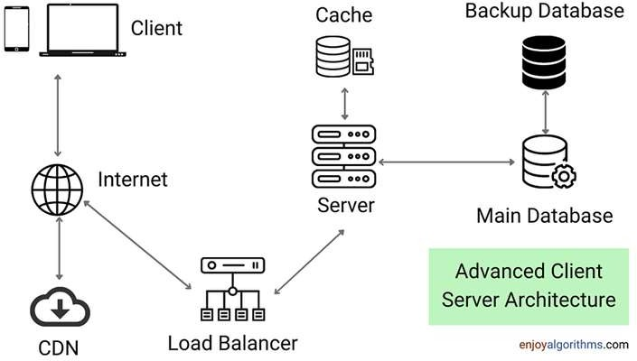

4.2

Communication Interfaces

* + 1. **User-to-Application Communication**

**User Interface (UI):** The app provides an intuitive interface for users to initiate emergency alerts, manage their profile, and view notifications. Users can activate the SOS function through a single tap or voice command.

**Input Methods:** Supports user interactions through touchscreen gestures, voice commands, and smartwatch inputs for wearable devices.

* + 1. **Application-to-Backend Communication**
* **Real-Time Database:** The app uses Firebase Realtime Databaseor Firestoreto manage user data and handle real-time updates. When an SOS alert is triggered, the app communicates with the backend to update the emergency status and share the user's location.

**APIs:** The app uses RESTful APIsand Firebase Cloud Functionsto interact with backend services, send alerts, and handle data processing.

**Location Services:** Communicates with Google Maps APIfor continuous location updates and geofencing to ensure accurate tracking of user whereabouts.

* + 1. **Application-to-Emergency Contact Communication**

**Notification Services:** Utilizes Firebase Cloud Messaging (FCM)and other push notification services to send real-time alerts and updates to emergency contacts via SMS, email, or in-app notifications.

**Multi-Channel Alerts:** Sends alerts through multiple channels to ensure that emergency contacts receive notifications even if one channel (e.g., in-app notifications) fails.

* + 1. **Application-to-Emergency Services Communication**

**Emergency Service API Integration:** The app integrates with local emergency services' APIs to forward critical information, such as user location and emergency type, for a swift response.

**Voice and Text Communication:** The app may include features for voice calls or text communication with emergency responders, leveraging VoIP and SMS gateways.

* + 1. **Wearable Device Communication**

**IoT Protocols:** The app communicates with connected wearable devices (e.g., smartwatches) using Bluetooth and Wi-Fi for real-time alerts and monitoring. This ensures that emergency notifications can be sent discreetly, even when the user is unable to access their phone.

**Wearable APIs:** Utilizes APIs from wearable manufacturers (e.g., Wear OS, Fitbit) for integration and data synchronization.

* + 1. **Security and Privacy Protocols**

**Encryption:** Data communication between the app and backend services uses HTTPSfor secure transmission. User data and location information are encrypted using AES and TLS protocols to maintain privacy and prevent unauthorized access.

**Authentication:** Firebase Authenticationprovides secure user login and access control, ensuring that only authorized users can access the app’s emergency services.

1. Overall Description

The Emergency Help Application is designed to provide users with a reliable and efficient tool for requesting assistance during emergencies. The project aims to enhance personal safety by integrating modern technologies to ensure timely response and secure communication between users, emergency contacts, and services.

The app is developed using Java and the Android SDK, offering an intuitive user interface that supports

easy navigation and quick emergency activation through single-tap and voice command features. It leverages Google Maps API for accurate geolocation tracking, enabling real-time updates of the user’s location to emergency contacts and responders. Firebase is utilized as the backend service to manage real-time data handling, user authentication, and notification delivery.

The app supports multi-channel communication through Firebase Cloud Messaging (FCM) to send alerts via SMS, email, and in-app notifications. Integration with wearable devices allows for discreet SOS activation, ensuring help can be called for even when the phone is out of reach. Predictive analytics using basic AI models help in risk assessment and enhancing user safety by identifying potentially high-risk scenarios.

Security and privacy are paramount in this project. User data and location information are protected using encryption protocols such as HTTPS, AES, and TLS, ensuring that user information is secure and private. Firebase Authentication is used for secure user login and access management.

This project not only focuses on real-time response and efficient communication but also emphasizes user adaptability and ease of use. The Emergency Help Application aims to empower users with the tools needed for fast and reliable emergency management, bridging the gap beMeen personal safety and immediate response through innovative use of mobile technology and cloud-based solutions.

* 1. **Product feature**
  2. Data Flow diagram

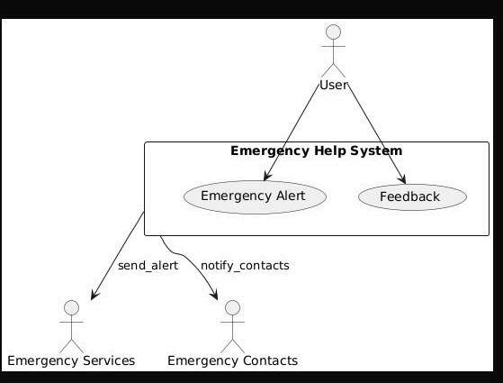LEVEL 0 DATA FLOW DIAGRAM

LEVEL l DATA FLOW DIAGRAM



User

Ale it Da*ta base

save al ert info

Emergency Help stem

U"ser Regist ra ton

Emergency Alert lnitation

store_fee dback

store_u ser_info

send_aIert notify_contacts

User Database

Emerpency’Sefuices Emer9enc 'Cnntacts

* 1. E-R Diagram

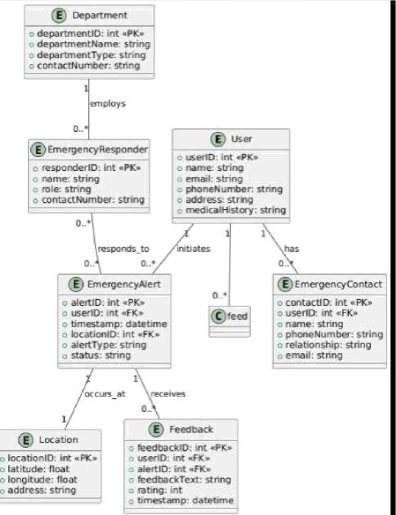

* 1. Class Diagram

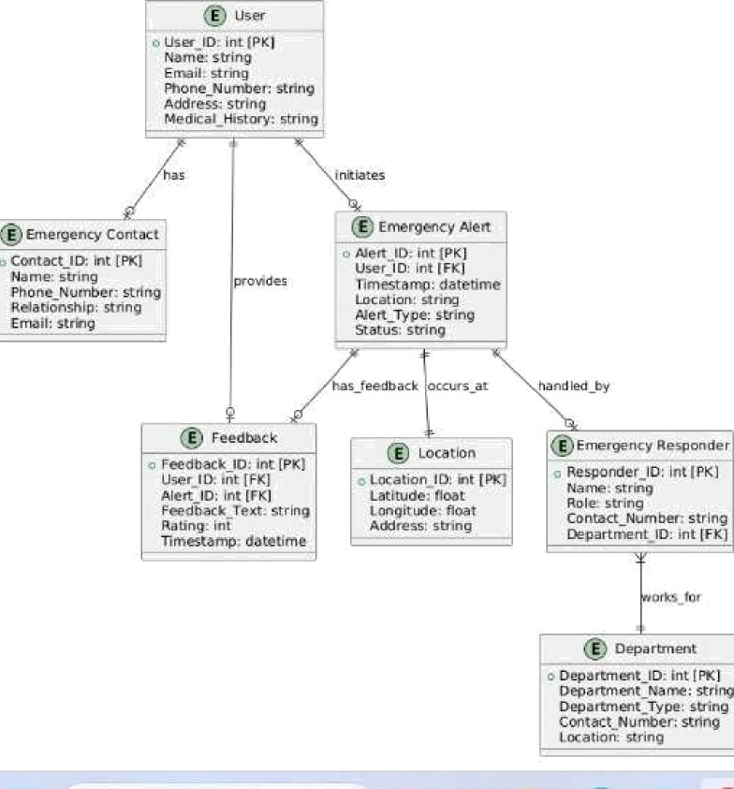

* 1. Use-Case Model

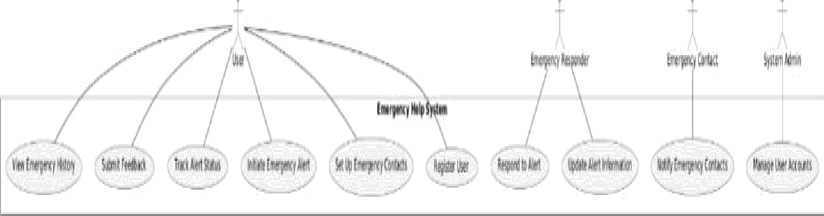

* 1. Behaviors Diagrams

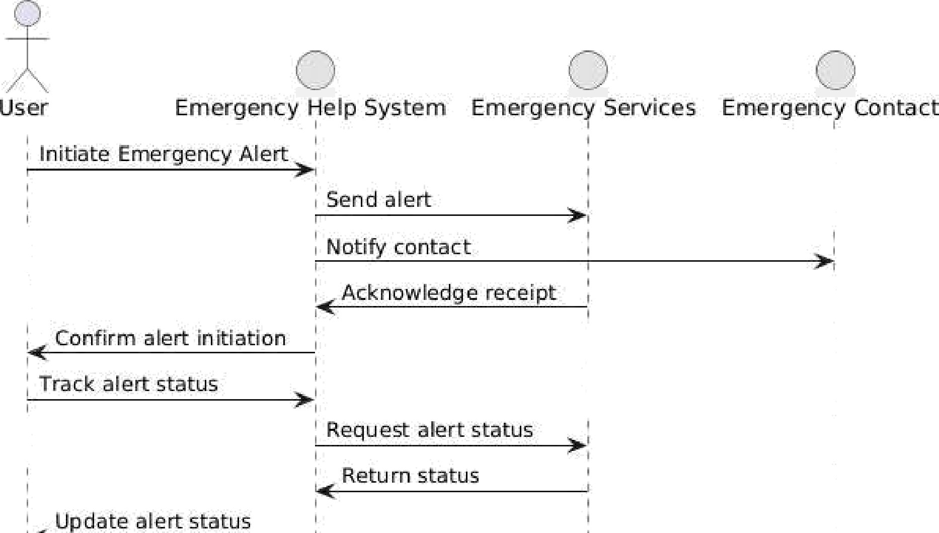

Emergent y Help System Emergency Services Emergency Contact

* 1. 
  2. Database Diagram

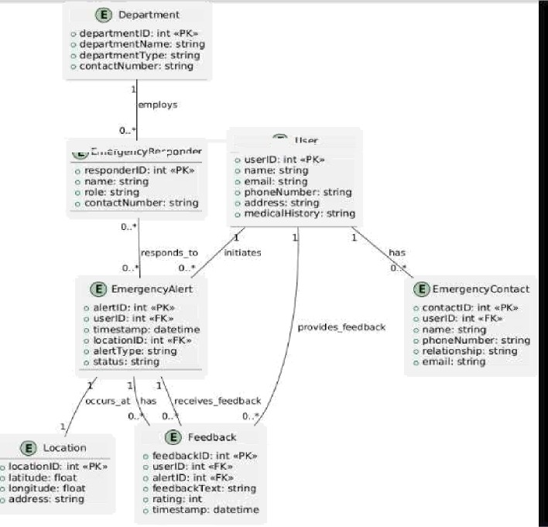

* 1. Assumptions and Dependencies

**Assumptions**

* + 1. **Internet Connectivity:** It is assumed that users will have access to a stable internet connection for the app to function effectively. The app’s performance relies on real-time data transmission, so a consistent network connection is necessary.
    2. **Device Compatibility:** The project assumes that users will have devices that meet the minimum specifications for running the application (e.g., Android OS version, screen size, and GPS capabilities).
    3. **User Proficiency:** It is assumed that users are reasonably familiar with smartphones and mobile apps, enabling them to navigate the app interface without difficulty.
    4. **Emergency Service Availability.** The app assumes the presence and responsiveness of local emergency services to act on alerts sent by the application.
    5. **Wearable Device Support:** It is assumed that users who opt to use wearable devices will have compatible devices that can communicate effectively with the app (e.g., smartwatches with Android compatibility).
    6. **User Consent:** Users will grant the necessary permissions for location tracking, notifications, and access to wearable devices.

**Dependencies**

1. Technology and Frameworks:
   * + Android SDK:The development framework for building the app.
     + Java: The primary programming language used for app development.
     + Firebase: Used for real-time data handling, user authentication, and push notifications.
     + Google Maps API:Used for geolocation and mapping services to track and share user locations.
2. Third-Party APIs and Services:

* Firebase Cloud Messaging (FCM):Used for sending real-time alerts and notifications to users and emergency contacts.
* Wearable Device APIs:Required for integration with smartwatches and fitness trackers (e.g., Wear OS, Fitbit API).

1. Security and Privacy Protocols**:**

* HTTPS and TLS: Used to ensure secure data transmission between the app and servers.
* AES Encryption:Applied for encrypting sensitive data, such as user location and personal information.

1. User Data and Privacy Regulations:

* The app must comply with local data privacy laws and regulations (e.g., GDPR, CCPA) to handle user information responsibly and ensure data protection.

1. Emergency Services and APIs:

* Integration with local emergency services’ APIs or systems to relay alerts and data for a prompt response.

1. Wearable Device Compatibility:

* The app must be compatible with specific wearable devices that support the required communication protocols for SOS activation and monitoring.

#### Supporting Information

* 1. Project Overview

The "Emergency Help App" is a mobile application designed to assist users during emergencies by providing timely and accurate help. The app integrates real-time location tracking, SOS alerts, and communication capabilities to ensure that users can quickly connect with the necessary support systems during critical situations.

* 1. Objectives
* Provide a reliable platform for users to send emergency alerts.
* Leverage real-time location services for accurate tracking.
* Ensure seamless communication between users and emergency contacts.
* Offer a simple and intuitive interface for quick access.

# Features

1. **SOS Alert System**

* Sends predefined emergency messages to saved contacts.
* Includes the user’s current location in the alert.

1. **Location Tracking**

* Uses Google Maps API to provide real-time tracking.
* Allows users to share their location with emergency services.

##### Firebase Integration

* **Authentication:** Ensures secure user login and registration.
* **Database:** Stores user profiles, emergency contacts, and alert history.

##### User-Friendly Interface

* Simple navigation and clear emergency buttons.
* Material design components for an intuitive user experience.
  1. **Technical Stack**

##### Frontend

* Android SDK
* Material Design Components

1. **Backend**

* Firebase Authentication
* Firebase Realtime Database

1. APIs

* Google Maps API
* Google Play Services

##### Languages

* Java
* XML (for UI)
  1. How It Works

1. User Registration/Login:
   * Users register or log in securely using Firebase Authentication.
2. Add Emergency Contacts:
   * Users can save trusted contacts in the app database.
3. Triggering an SOS Alert:
   * By pressing the SOS button, the app sends an alert with the user’s location to the saved contacts.
4. Location Sharing:
   * Real-time tracking is enabled to help responders locate the user quickly.

## Use Cases

**Personal Safety:** For individuals feeling unsafe or threatened, such as during travel or at night.

**Medical Emergencies:** Quickly contacting family or medical services during health crises.

**Natural Disasters:** Facilitating communication and location sharing in challenging conditions.

1. **Potential Enhancements**

Integration of AI/ML for predictive analysis of emergency trends.

Offline capabilities to send alerts via SMS if internet access is unavailable. Multi-language support for broader accessibility.

# Challenges and Solutions

##### Ensuring High Accuracy:

Challenge: Accurate location tracking in areas with weak GPS signals.

Solution: Utilize Google Play Services’ fused location provider for enhanced precision.

1. Data Privacy:

Challenge: Safeguarding sensitive user data.

Solution: Implement secure data encryption and comply with GDPR guidelines.

##### Reliability in Emergencies:

Challenge: Ensuring the app functions under low network conditions. Solution: Implement fallback mechanisms like SMS-based alerts.

1. **Conclusion**

The "Emergency Help App" is a vital tool for enhancing personal safety and ensuring timely assistance during critical situations. With its integration of advanced APIs and a user-focused design, the app provides a comprehensive solution for managing emergencies effectively. Further developments and enhancements will continue to improve its reliability and reach.

1. Concerns / Queries / Doubts if any:
   1. What algorithms or technologies can we use to achieve the required 90% accuracy for emergency detection and response?

Ans : To achieve 90% accuracy in emergency detection and response, you can use the following:

1. **Machine Learning Models:** Train classification models (e.g., Random Forest, XGBoost, or Neural Networks) on labeled datasets of emergency scenarios.
2. Deep **Learning:** Use CNNs for image recognition (e.g., detecting accidents) and RNNs for sequence-based data (e.g., analyzing call transcripts).
3. **Natural Language Processing (NLP):** Analyze user inputs like text or voice commands to identify emergencies accurately.
4. **Sensor Fusion:** Combine data from GPS, accelerometers, and gyroscopes to detect sudden changes indicative of emergencies.
5. **Anomaly Detection:** Use statistical or unsupervised techniques (e.g., Autoencoders) to identify unusual patterns that signal emergencies.

Cloud services like AWS SageMaker, Google Cloud AI, or Microsoft Azure AI can streamline deployment.

* 1. How can we ensure reliable and accurate location tracking in real-time? Ans: Ensure reliable real-time location tracking with:
     1. GPS **and A-GPS** for precision.
     2. **Sensor Fusion** combining GPS, accelerometers, and gyroscopes.
     3. **Fallbacks** like Wi-Fi and cellular triangulation.
     4. **Error Correction** using Kalman Filters.
     5. Geofencing for defined area tracking.
     6. **Testing** in diverse environments.